Week 7 – Introduction to Docker and Containers

- Checking Docker Installation:
This command checks whether Docker is installed on the system and displays the installed Docker version.
Command: docker –version
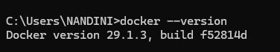

- Verifying Docker Engine Status:
This command displays Docker client and server details and confirms whether the Docker Engine (daemon) is running.
Command: docker info
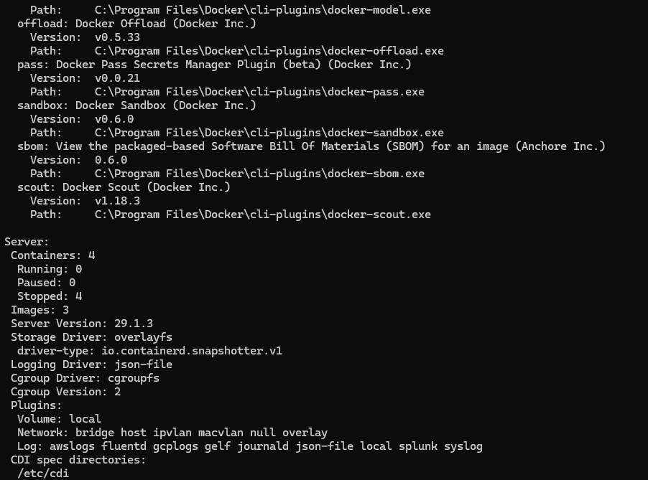

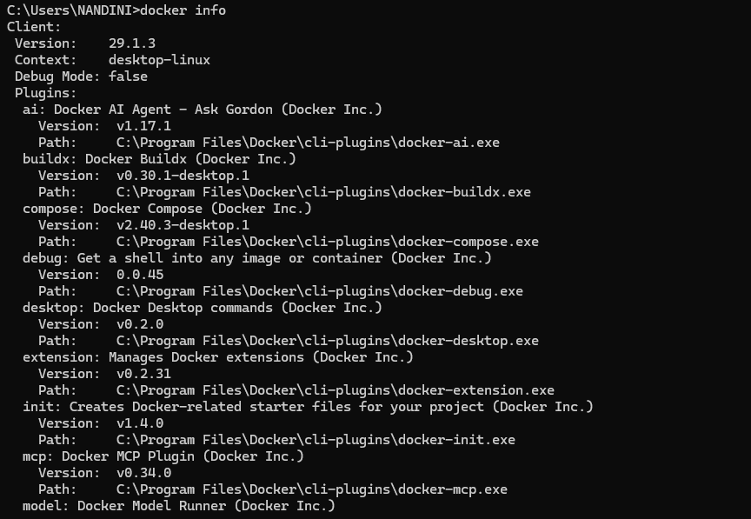

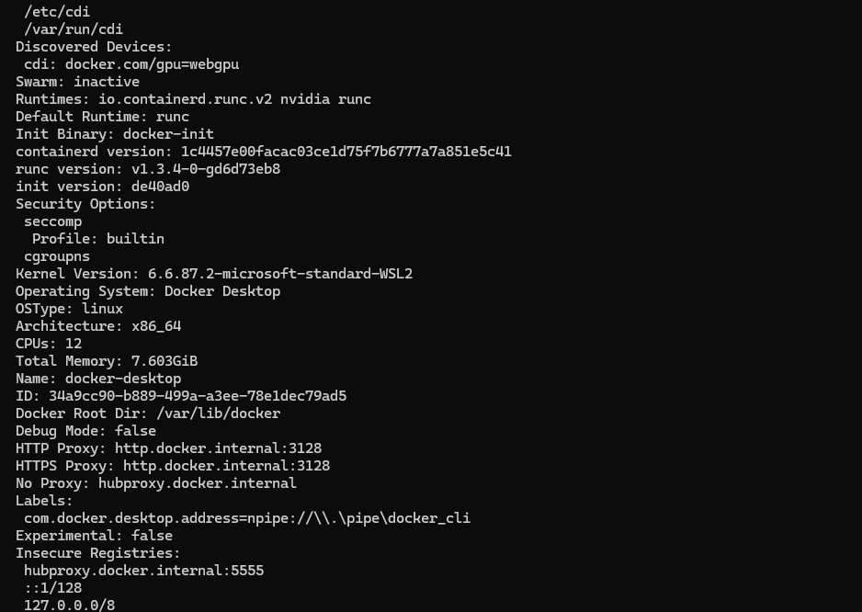

- Running Hello-World Container:
This command pulls the hello-world image from Docker Hub and runs a test container to verify Docker installation.
Command: docker run hello-world
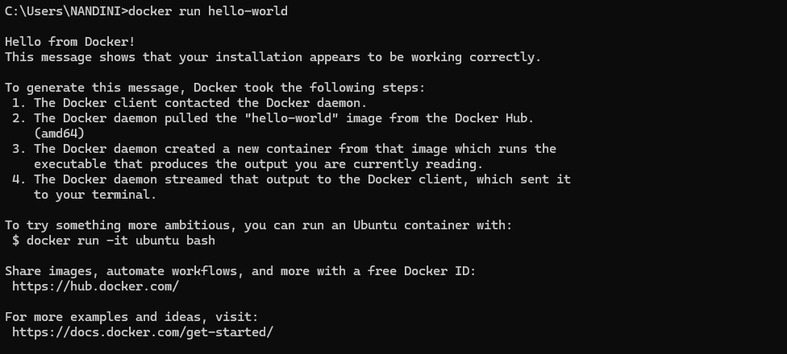
4.Pulling and Running Python Image:
This command downloads the official Python image from Docker Hub and starts an interactive Python container.
Command: docker run -it python
print("Docker + Python works!")
exit()
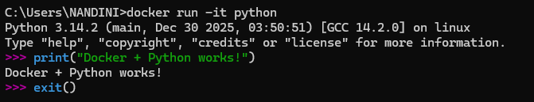

5.Listing Docker Images:
This command displays all Docker images available locally on the system.
Command: docker images
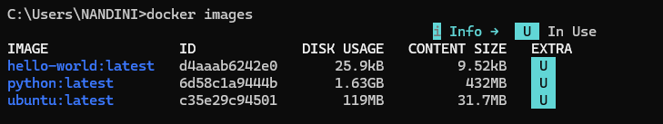

6. Listing All Containers:
This command lists all Docker containers including running and stopped containers.
Command: docker ps -a
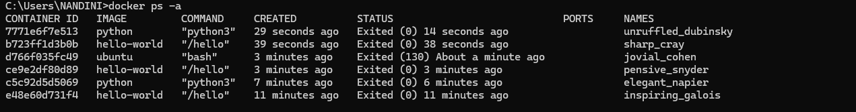

7. Pulling and Running Ubuntu OS Container:
This command pulls the Ubuntu operating system image and opens an interactive Linux shell inside the container.
Command: docker run -it ubuntu bash
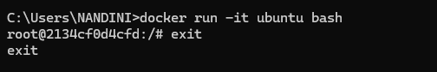

Conclusion:
Docker was successfully installed and configured on the system.
Different operating system images such as hello-world, Python, and Ubuntu were pulled from Docker Hub and executed as containers.
This experiment helped in understanding Docker, containerization, and running applications in isolated environments.

